**Bharati Vidyapeeth (Deemed to be University) Medical College, Pune.**

**List of documents required at the time of admission to MBBS**

**Candidates has to submit following original documents along with its two sets of self-attested photocopies and set of soft copy in PDF format.**

|  |  |
| --- | --- |
| *1 | Allotment letter issued by NMC |
| *2 | Admit Card of Exam issued by NTA |
| *3 | Result/Rank letter issued by NTA |
| *4 | NEET Application Form/Confirmation Form |
| *5 | Aadhar Card Xerox Copy |
| *6 | Proof of Identity (Aadhar/PAN/Driving license/Passport) |
| *7 | Date of Birth certificate (If Matric certificate does not bear the same) |
| *8 | Class 10th Mark sheet /Class 10th board Passing certificate |
| *9 | Class 11th Mark sheet |
| *10 | Class 12th Mark sheet/ Class 12th board Passing certificate |
| *11 | Medical fitness certificate (Format is on college website) |
| *12 | Proof of Nationality of India: - **Passport/Domicile/Nationality Certificate** |
| 13 | Migration certificate (Wherever applicable) |
| 14 | Transfer certificate /Leaving certificate |
| *15 | Candidate should also bring the following certificate if applicable  a) SC/ST Certificate b) OBC Certificate c) Disability Certificate d) EWS Certificate |
| *16 | Gap certificate (Wherever applicable) |
| 17 | Conduct certificate |
| *18 | Affidavit for Anti-ragging by students & parents (To be generated online in college) |
| *19 | Eight (8) passport sized photographs same as affixed on the application form. |
| *20 | Fees Payment (Demand draft/ NEFT/ Online payment) |
| *21 | Oracle (Student Database Software) Registration (To be done in college) |
| *22 | For NRI/OCI candidates appearing for Deemed Universities following documents are mandatory |
|  | (a) Passport copy of sponsorer, embassy certificate  (b) Sponsorship affidavit (stating that sponsorer is ready to bear the expenses for the whole duration of study)  (c) Relationship affidavit (Relation of candidate with the sponsorer) |
| *23 | Undertakings (To be issued in college) |
|  | a) From parents regarding fee payment  b) From parents regarding attendance  c) From candidate |

Name and Signature of Staff who verify Documents

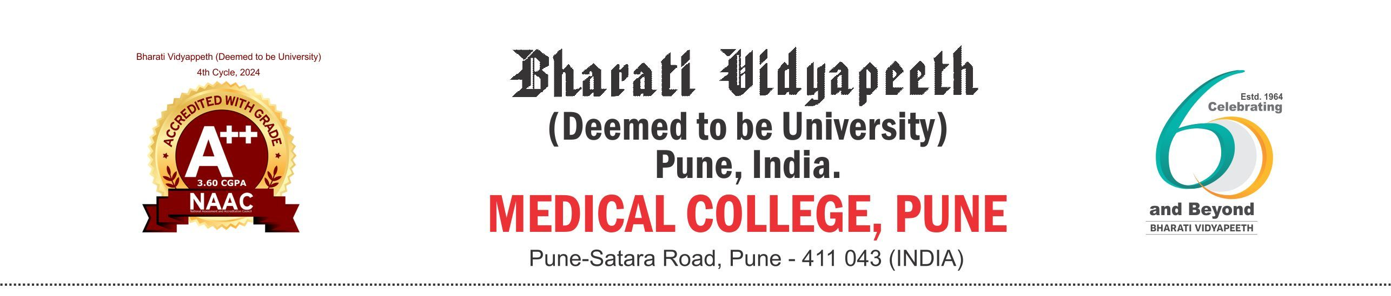

**Admission for M.B.B.S. Course Academic Year 2025-2026**

**(Undertaking from Parents – Regarding Payment of Fees)**

(**To be taken from all the parents at the time of counselling and admission)**

I, ______________________________________________ Father/Mother/Guardian of Mr./Miss __________________________________________ who is seeking admission to the 1st year M.B.B.S. course in Bharati Vidyapeeth (Deemed to be University), Medical College, Pune hereby undertake that –

1. I am aware of the University/College fee structure of the MBBS course and the duration of the course.

2. I shall pay all the annual fees as prescribed by the University/College on time and well within the specified time limit.

3. Failure on my part to pay the fee in time may result in penalty/appropriate action against me including withholding to appear for the examination and I take full responsibility in ensuring the payment of fee in time. In the event of any action taken against me for default in payment of fee, I will not resort to any other recourse.

4. If I leave the course for any reason, I am aware that I have to deposit the remaining fee for the entire course. (4½ Years)

This undertaking is dated on __________________.

Signature : _____________________________

Name : __________________________________

Designation : __________________________________

Contact Nos.: __________________________________

E-mail : __________________________________

Address : __________________________________

__________________________________



**Admission for M.B.B.S. Course**

**Academic Year 2025-2026**

**Undertaking from Parents –Regarding Attendance**

**(To be taken from all the parents at the time of counselling and admission)**

I, ______________________________________________ Father/Mother/Guardian of Mr./Miss ___________________________________________ who is seeking admission to the 1st year M.B.B.S. course in Bharati Vidyapeeth (Deemed to be University), Medical College, Pune hereby undertake that –

1. I am aware that as per the University and National Medical Commission norms a minimum of 75% attendance for theory and 80% for practical is compulsory.

2. I am also aware that if the attendance of my ward is less than the norms as above, his/her term will not be granted and he/she may not be permitted to appear for university examination.

3. I will not have objections for any disciplinary action, fine/penalty that may be levied on my son/daughter for the irregularities that he/she may have done. I will agree and abide by the decision taken by the college authorities.

4. I confirm that my ward is physically and mentally fit to attend this course and is in a position to cope up with the course requirement.

This undertaking dated ________________.

**Sign.: ____________________________**

**Name: ____________________________**

**Designation: _______________________**

**Contact Nos.: ______________________**

**E-mail: ___________________________**

**Address: __________________________**

**___________________________________**

**___________________________________**

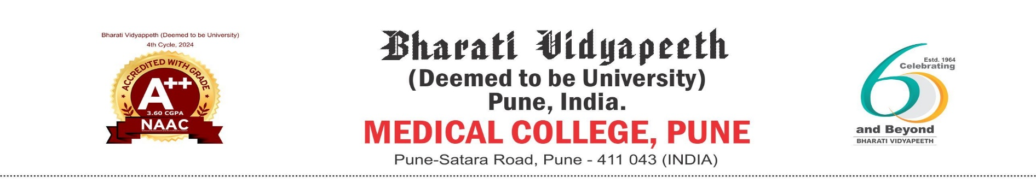

# **UNDERTAKING FROM THE CANDIDATE (2025-2026)**

I _______________________________________________________________________ Son/Daughter of ____________________________________________________ who has been given admission to the MBBS course of the Bharati Vidyapeeth (Deemed to be University) Medical College, Pune for the year 2025-2026 hereby solemnly affirm and give the following undertaking.

1. I am a citizen of India/NRI Student/NRI Sponsored Student.
2. I will be completing 17 years of age on or before 31st December 2025.
3. I studied classes 11 and 12 in India and passed the class 12 (Intermediate/Pre-University/Higher Secondary/Plus two equivalent) examination.
4. I have obtained ---------% marks in Physics, Chemistry and Biology taken together and passed in the subject of English and
5. I am eligible for NEET UG exam

D) I am aware that the admission given to me will be confirmed only when it is finally approved by the National Medical Commission Bharati Vidyapeeth Deemed to be University Medical College, Pune.

1. I have studied and understood the rules governing counselling, admission procedure, fee structure and refund of fees and agree to abide by the rules.
2. I am aware that my admission can be cancelled,

* If it is found that the documents regarding eligibility or any other relevant documents submitted by me for admission purpose are false or fabricated, etc.
* If I do not join the course on the specified date.
* Any other valid reason.
* If my admission is cancelled, I will have to pay fees of **FOUR & HALF YEARS**

1. If admitted to any of the Institutions of the Bharati Vidyapeeth (Deemed to be University), I will abide by all its rules and regulation, especially those governing discipline, attendance, dress code, examinations, anti-ragging and payment of fees. I understand that failure to comply the rules and regulation will invite an appropriate disciplinary action from the institutional authorities.
2. I am fully aware that if my admission to this course is found invalid by any authority of State Govt./Central Govt./NMC/or any other competent authority I will accept that decision and will not have any claim for this admission. I am aware that the college will not accept any responsibility in this matter. In the event of this I will have to pay entire course fess (Four & half Years)

**Name of the Candidate :**……………………………………………………………………..

Signature of Parent / Guardian Signature of the Candidate Name:

Place: - Pune

Date: - / /2025



**UNDERTAKING (2025-2026)**

I Mr./Miss ___________________________________________________ did not submit the following certificates in original at the time of Counselling and admission to the MBBS course, at Bharati Vidyapeeth (Deemed to be University) Medical College, Pune. I am aware that this is a mandatory requirement for the confirmation of my admission to MBBS course.

I hereby undertake that I will submit these documents within 30 days, failing which my **I MBBS result will be withheld or admission may be cancelled & if I cancelled will have to pay 4½ year fees.**

**Certificates not submitted**: -

1. ___________________________
2. ___________________________
3. ___________________________
4. ___________________________
5. ___________________________
6. ___________________________

|  |  |
| --- | --- |
| Signature & Name of Parent/Guardian | Signature & Name of Candidate |
|  |  |
| Date: / /2025 |  |
| Place: Pune |  |